**THE DESIGN AND ANALYSIS OF LARGE SOLAR PV FARM CONFIGURATIONS WITH DC CONNECTED BATTERY SYSTEMS**

**ABSTRACT**

Typically, solar inverters curtail or “clip” the available power from the PV system when it exceeds the maximum ac capacity. This paper discusses a battery system connected to the dc-link of an inverter to recuperate this PV energy. Contrary to conventional approaches, which employ two dc-dc converters, one each for the battery and solar PV system, the proposed configuration utilizes a single dc-dc converter capable of simultaneously operating as a charge controller and a maximum power point tracking (MPPT) tracking device. In addition to improving the overall system capacity factor, increasing the conversion efficiencies and ensuring MPPT stability, the proposed configuration offers a simple solution for adding energy storage to existing PV installations. With this configuration, the excess power that will otherwise be curtailed due to inverter rating limitations is stored in the battery and supplied to the grid during periods of reduced irradiance. Moreover, a systematic methodology for sizing a dc-bus connected battery to minimize total PV energy curtailed was developed using an annual PV generation profile at the Louisville Gas and Electric and Kentucky Utilities (LG&E and KU) E.W. Brown solar facility at Kentucky. The detailed behavior of the proposed system and its power electronics controls and operations were validated with case studies developed in MATLAB for variable power generation and PV output power smoothing.

**Index Terms**—PV, battery, MPPT, PV curtailment, dc-dc converter, charge controller, energy storage, battery sizing, MATLAB .

**INTRODUCTION**

The photovoltaic (PV) energy installations are fast-growing both for residential applications, as well as for utility-sized power plants . Solar PV generation is intermittent in nature, and much of the associated research focuses on employing battery energy storage systems (BESS) in order to mitigate this inherent limitation. Power electronic devices play major roles in PV and BESS integration, fulfilling multiple functions including ac-dc transformation, PV maximum power point tracking (MPPT), and battery charge control . Analyses have shown substantial benefits of single-stage grid-connected PV systems over two-stage PV systems, some of which include: lower cost, smaller system size, and higher efficiency . Configurations with PV systems incorporating BESS typically introduce two additional dc-dc converters, with losses in the supplementary components . Compared to hybrid PV and battery systems presented in , the proposed configuration, which requires only one dc-dc converter in addition to the grid connected inverter, constitutes a simple and potentially cost effective solution for integrating BESS with conventional PV systems. Other configurations for battery integrated PV systems using a single dc-dc converter have been presented in literature. In [13], the battery is directly connected to the dc-link of a two-stage converter, which ensures simplicity, but leads to additional losses in the dc-dc converter when the battery is not operational, further affecting the battery over-voltage protection and the effectiveness of the control for the battery charge and discharge operations. This paper introduces a configuration for integrating BESS with multi-MW grid-connected PV systems, in which the battery is connected to the dc-link of the PV inverter via a dc-dc converter, which simultaneously serves as a charge controller and MPPT device. An approach for determining the ratings of a BESS connected to the dc-bus of an experimental PV system is proposed. This work is an expanded follow-up to a previous conference paper by the same group of authors [14]. Additional contributions include detailed calculations of curtailed solar energy due to inverter rating limitations, the development of a sizing approach for the battery to maximize solar energy utilization based on annual solar PV generation data from the LG&E and KU site. The proposed configuration is compared with other established setups including the LG&E and KU E.W. Brown universal solar facility system, wherein the PV array and BESS are connected to the grid through individual inverters, as described in the second section of this paper. Section III presents the modeling of a simplified BESS integrated PV system and a general approach for battery sizing. Sections IV and V describe the proposed system components and control. Sections VI and VII include a comprehensive examination of the proposed configuration and controls for variable power generation and PV output power smoothing, which was simulated on a sped-up time scale .

# LITERATURE REVIEW

Electricity is one the most essential needs for humans in the present. Conversion of solar energy into electricity not only improves generation of electricity but also reduces pollution due to fossil fuels. The output power of solar panel depends on solar irradiance, temperature and the load impedance. As the load impedance is depends on application, a dc-dc converter is used for improving the performance of solar panel. The solar irradiance and temperature are dynamic. Hence an online algorithm which dynamically computes the operating point of the solar panel is required. The efficient conversion of solar energy is possible with Maximum Power Point Tracking (MPPT) algorithm. There are various MPPT algorithms such as Perturb and Observe, Incremental Conductance etc. The various algorithms in MPPT and their topology is discussed in this paper. The comparison between these algorithms is also given in this paper

Global environmental concerns and the escalating demand for energy, coupled with steady progress in renewable energy technologies, are opening up new opportunities for utilization of renewable energy resources. Solar energy is the most abundant, inexhaustible and clean of all the renewable energy resources till date. The power from sun intercepted by the earth is about 1.8 × 1011 MW, which is many times larger than the present rate of all the energy consumption. Photovoltaic technology is one of the finest ways to harness the solar power. This paper reviews the photovoltaic technology, its power generating capability, the different existing light absorbing materials used, its environmental aspect coupled with a variety of its applications. The different existing performance and reliability evaluation models, sizing and control, grid connection and distribution have also been discussed New technical analysis for the monthly solar energy available and the monthly energy pattern factor (E.P.F.) for the station was made. Moreover, calculations show that the annual mean energy density available was 200 kWh/m2 at 70 m height in Aswan region, that is very high potential and suitable for large electricity generation.

Furthermore, the monthly plant load factor (PLF) has been determined. Locally and technologically suitable wind turbine for this station must have rated power greater than 1 MW at 100 m height above the ground level.

The aim of this research, was to study the possibility of construction a wind farm extending up to a capacity of 45 MW. Where 30 wind turbines model (Fuhrländer FLMD 77) with a capacity of 1.5 MW were considered at Aswan station. , the energy output 152 GWh/year can be generated from 45 MW wind farm in this site. Then additionally, the expected electricity generation cost was 2€ cent/kWh. This specific price is economically valuable according to the national tariff system.

Since the harmful effects of climate warming on our planet were first observed, the use of renewable energy resources has been significantly increasing. Among the potential renewable energy sources, photovoltaic (PV) system installations keep continuously increasing world-wide due to its economic and environmental contributions. Despite its significant benefits, the inherent variability of PV power generation due to meteorological parameters can cause power management/planning problems. Thus, forecasting of PV output data (directly or indirectly) in an accurate manner is a critical task to provide stability, reliability, and optimization of the grid systems. In considering the literature reviewed, there are various research items utilizing PV output power forecasting. In this study, a systematic literature review based on the search of primary studies (published between 2010 and 2020), which forecast PV power generation using machine learning and deep learning methods, is reported. The studies are evaluated based on the PV material used, their approaches, generated outputs, data set used, and the performance evaluation methods. As a result, gaps and improvable points in the existing literature are revealed, and suggestions which include novelties are offered for future works.

**II. BATTERY INTEGRATED PV SYSTEMS**

Battery energy storage systems may be connected to either the ac or dc terminals of a grid-tied PV system. The ac connected battery units, which require their inverter, introduce the possibility of having an independent operation of the BESS and PV systems as well as the ease of integrating BESS into an existing PV system [15], [16]. However, the configuration is

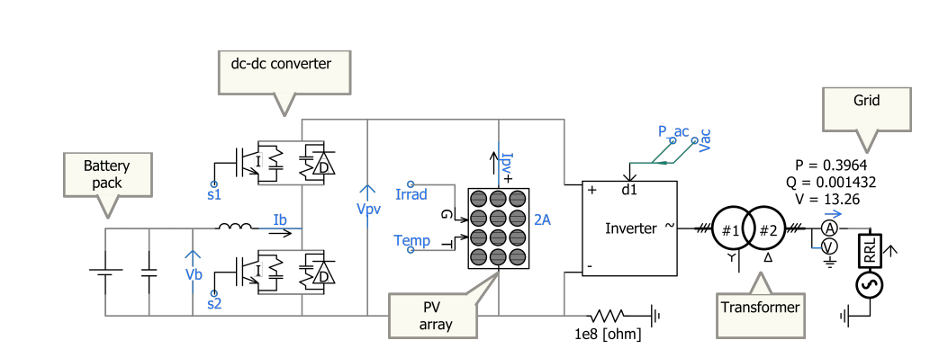

During the normal operation of the microgrid, the photovoltaic cells and wind generators on the AC and DC bus provide the electrical energy required by the load, and the storage battery is used to stabilize the fluctuation of the generated power. The excess power of the microgrid is delivered to the grid, and the shortfall is provided by the grid. By optimizing the installed capacity of photovoltaic cells, wind turbines and storage batteries and their distribution on both sides of AC and DC, the economic cost of microgrid operation is optimized and the loss of the converter is reduced.

**MODELING ANALYSIS OF CAPACITY OPTIMIZATION CONFIGURATION MODEL:**

On the basis of ensuring the safe and stable operation of the microgrid, the self-balancing rate, the energy waste rate and the converter loss between the AC and DC buses are used as constraints, and the minimum economic cost of the microgrid is used as the objective function to establish its capacity optimization configuration mathematics model.

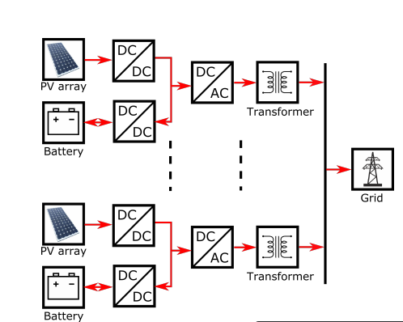

1. **Mathematical Models of Different Types of Distributed Power**

**Microgrid :**  is connecting and controlling multiple [microgrids](https://en.wikipedia.org/wiki/Microgrid) within a certain range of distance (e.g. neighborhood) to either gain economic benefits when the [microgrids](https://en.wikipedia.org/wiki/Microgrid) are connected to the grid in normal operation (e.g. exchange power with lower prices instead of the grid price) or to mitigate power outage during blackout by maintaining supplying the critical loads. The connection between the micro-grids in the cluster should be set up in a specific way according to a predefined algorithm and the existing conditions of the system .

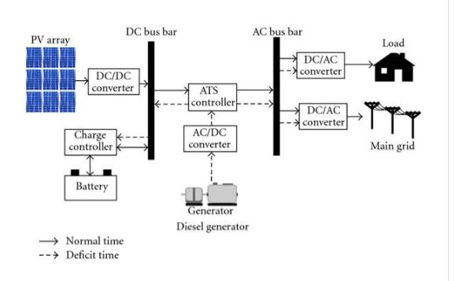

A micro grid is a local [electrical grid](https://en.wikipedia.org/wiki/Electrical_grid) with defined electrical boundaries, acting as a single and controllable entity. It is able to operate in grid-connected and in island mode. A 'Stand-alone micro grid' or 'isolated micro grid' only operates [off-the-grid](https://en.wikipedia.org/wiki/Off-the-grid) and cannot be connected to a wider electric power system.

A grid-connected micro grid normally operates connected to and synchronous with the traditional [wide area synchronous grid](https://en.wikipedia.org/wiki/Wide_area_synchronous_grid) (macro grid), but is able to disconnect from the interconnected grid and to function autonomously in "island mode" as technical or economic conditions dictate. In this way, they improve the security of supply within the micro grid cell, and can supply emergency power, changing between island and connected modes.This kind of grids are called 'is land able micro grids'.

A stand-alone micro grid has its own sources of [electricity](https://en.wikipedia.org/wiki/Electricity), supplemented with an [energy storage system](https://en.wikipedia.org/wiki/Battery_storage_power_station). They are used where power transmission and distribution from a major centralized energy source is too far and costly to operate.They offer an option for rural electrification in remote areas and on smaller geographical islands. A stand-alone micro grid can effectively integrate various sources of [distributed generation](https://en.wikipedia.org/wiki/Distributed_generation) (DG), especially [renewable energy sources](https://en.wikipedia.org/wiki/Renewable_energy) (RES).

Control and protection are difficulties to microgrids, as all [ancillary services](https://en.wikipedia.org/wiki/Ancillary_service) for system stabilization must be generated within the microgrid and low short-circuit levels can be challenging for selective operation of the protection systems. An important feature is also to provide multiple useful energy needs, such as heating and cooling besides electricity, since this allows energy carrier substitution and increased energy efficiency due to waste heat utilization for heating, domestic hot water, and cooling purposes (cross sect oral energy usage).

Definitions

[United States Department of Energy](https://en.wikipedia.org/wiki/United_States_Department_of_Energy) Microgrid Exchange Group defines a microgrid as a group of interconnected loads and distributed energy resources (DERs) within clearly defined electrical boundaries that acts as a single controllable entity with respect to the grid. A microgrid can connect and disconnect from the grid to enable it to operate in both connected or island-mode.

The [Berkeley Lab](https://en.wikipedia.org/wiki/Berkeley_Lab) defines: "A microgrid consists of energy generation and energy storage that can power a building, campus, or community when not connected to the electric grid, e.g. in the event of a disaster." A microgrid that can be disconnected from the utility grid (at the 'point of common coupling' or PCC) is called an 'island able microgrid'.

A EU research project[[9]](https://en.wikipedia.org/wiki/Microgrid#cite_note-Microgrids_Architectures_and_Control-9) describes a micro grid as comprising [Low-Voltage (LV)](https://en.wikipedia.org/wiki/Low_voltage) distribution systems with distributed energy resources (DERs) ([microturbines](https://en.wikipedia.org/wiki/Microturbine), [fuel cells](https://en.wikipedia.org/wiki/Fuel_cell), [photovoltaics](https://en.wikipedia.org/wiki/Photovoltaics) (PV), etc.), storage devices ([batteries](https://en.wikipedia.org/wiki/Electric_battery), [flywheels](https://en.wikipedia.org/wiki/Flywheel_energy_storage)) energy storage system and flexible loads. Such systems can operate either connected or disconnected from the main grid. The operation of micro sources in the network can provide benefits to the overall system performance, if managed and coordinated efficiently.

[Electropedia](https://en.wikipedia.org/wiki/Electropedia) defines a micro grid as a group of interconnected loads and distributed energy resources with defined electrical boundaries, which form a local electric power system at distribution voltage levels, meaning both low and medium voltage up to 35 kV. This cluster of associated consumer and producer nodes acts as a single controllable entity and is able to operate in either grid-connected or island mode.[[3]](https://en.wikipedia.org/wiki/Microgrid#cite_note-IEV-3)

A stand-alone micro grid or isolated micro grid, sometimes called an "island grid", only operates [off-the-grid](https://en.wikipedia.org/wiki/Off-the-grid) and cannot be connected to a wider electric power system. They are usually designed for geographical islands or for rural electrification.[[4]](https://en.wikipedia.org/wiki/Microgrid#cite_note-iec-isolated_microgrid-4) In many non-industrialized countries, micro grids that are used to provide access to electricity in previously un electrified areas are often referred to as "[mini grids](https://en.wikipedia.org/wiki/Mini-grid)"

where: SOC (t ) and SOC (t -1) are the state of charge at t and t-1;  ， d and  c are the battery's self-discharge rate, charging efficiency and discharge efficiency; Er is the battery's rated capacity, kW h ; and are the discharge power and charging power of the battery at time t, kW ; t is the sampling step length, which is 1h in this paper. B. Cost function of Microgrid Operation Economy Due to the high cost of distributed power, the primary goal of optimized configuration of microgrid is to reduce its operating cost on the basis of satisfying reliable power supply. The initial construction investment of microgrid is relatively large, but the maintenance cost during the later operation is less, so the average annual cost within the service life is used as the cost function：



where: is the total annual cost of the micro-grid; is the total installation cost of all equipment of the micro grid converted to the cost of each year. Which is:



where: M is the total types of equipment initially invested in the micro grid;Ni,Ci and Vi and are the number, installation cost and service life of each type of equipment; r is the discount rate, which is 8%. The annual operation and maintenance costs are related to the installed capacity of various equipment,



where: is the annual operation and maintenance cost of each equipment of each type. The cost of electricity purchase and sale of the micro grid is the difference between the cost of purchasing electricity from the grid and the income from selling electricity to the grid each year:



where: and are the total electricity purchased from and sold to the grid by the micro grid each year; and 571 Authorized licensed use limited to: Western Sydney University. Downloaded on June 15,2021 at 12:35:14 UTC from IEEE Xplore. Restrictions apply. are the electricity prices for buying electricity from the grid and selling electricity to the grid. C. Evaluation Index of Microgrid Economy 1) Self-balance rate of microgrid The self-balancing rate of the microgrid is the ratio of the renewable energy generation in the microgrid to the total load demand of the microgrid, and it is used to describe the dependence of the microgrid on the grid. The higher the self-balancing rate, the lower the dependence on the power grid. When the power grid fails, the island-operated microgrid can better guarantee the load demand. This paper also considers the self-balance rate of the AC side and the DC side respectively. By increasing the self-balance rate on both sides, the electric energy flowing through the converter between the AC and DC buses can be reduced. This way, the number of installed converters and power loss can be reduced, and the load demand on both sides can be guaranteed to the greatest extent when the converter fails. Self-balance rate of microgrid:

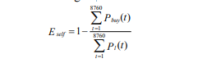

### Remote off-grid microgrid:

These micro-grids are generally not designed or intended to connect to the [macrogrid](https://en.wikipedia.org/wiki/Electrical_grid" \o "Electrical grid) and instead operate in an island mode at all times because of economic issues or geographical position. Typically, an "off-grid" micro grid is built in areas that are far distant from any transmission and distribution infrastructure and, therefore, have no connection to the utility grid.Studies have demonstrated that operating a remote area or islands' off-grid micro grids, that are dominated by renewable sources, will reduce the level sized cost of electricity production over the life of such micro grid projects. In some cases, off-grid micro grids are indeed incorporated into a national grid or 'macro grid', a process that requires technical, regulatory and legal planning.

Large remote areas may be supplied by several independent micro grids, each with a different owner (operator). Although such micro grids are traditionally designed to be energy self-sufficient, [intermittent](https://en.wikipedia.org/wiki/Intermittent_power_source) renewable sources and their unexpected and sharp variations can cause unexpected power shortfall or excessive generation in those micro grids. Without energy storage and smart controls, this will immediately cause unacceptable voltage or frequency deviation in the micro grids. To remedy such situations, it is possible to interconnect such micro grids provisionally to a suitable neighboring micro grid to exchange power and improve the voltage and frequency deviations. This can be achieved through a power electronics-based switch after a proper synchronization[]](https://en.wikipedia.org/wiki/Microgrid#cite_note-23) or a back to back connection of two power electronic converters[[24]](https://en.wikipedia.org/wiki/Microgrid#cite_note-24) and after confirming the stability of the new system. The determination of a need to interconnect neighboring micro-grids and finding the suitable micro grid to couple with can be achieved through optimization or decision making[[26]](https://en.wikipedia.org/wiki/Microgrid#cite_note-26) approaches.

## Because remote off-grid micro grids are often small and built from scratch, they have the potential to incorporate best practices from the global electricity sector and to incorporate and drive energy innovation.It is now common to see remote off-grid micro grids being largely powered by renewable energy and operated with customer-level smart controls, something that is not always easy to implement in the larger power sector because of incumbent interests and older, preexisting infrastructure.

## The Solar Energy Resource

The sun is the main energy source which is responsible for supporting all life activity around the world, such as the Earth’s thermal comfort, photosynthesis in plants and the whole biochemical system. The sun emits its energy in form of electromagnetic radiation and after reaching the earth surface it is converted to other types of energy sources and used for many purposes.

The human beings are using the energy from the Sun in two main ways, i.e. for photo-electric generation and thermal conversion. These applications represent one big leap for the solution of the world energy shortage. For example, it is estimated that out of 1.76x1015 TW of raw solar energy striking the Earth, 60 TW can be economically converted into electricity and, considering that the estimation of the world energy demand until 2050 is about 25-30 TW, it is clear that only solar energy is enough to supply all demand and to free the world of fossil fuels .

### Photoelectric Conversion

This fundamental photoelectric conversion consists of the escape of electrons (electric current) from the clear metal surface when the light with certain frequency strikes on this surface.

### The Photovoltaic System

A PV system is a composition of all the devices used to convert solar photons directly into electricity which are: Solar panel, storage unit, charge/discharge regulator and inverter if necessary to convert direct current (DC) to alternating current (AC). In some cases, depending on the purpose storage might not be necessary (e.g. connection to the grid). The key element of a PV system is the solar cell. This element is responsible for the conversion of solar radiation into electricity and its function is based on the photoelectric effect[1](#_bookmark18) that consists on electrical generation by certain materials when exposed to the light.The first silicon solar cell (SC) was discovered by a French physicist, Edmond Becquerel in 1839. Becquerel experiments showed that certain materials produce a small amount of electricity when exposed to the light. This effect was firstly studied in metals such as silicon with performance of about 2%. The research proceeded and in 1954 was achieved a silicon solar cell with an efficiency of about 6%, reported by Chapin, Fuller and Pearson . Regarding its application, the SC’s were firstly used to charge batteries of the United States Satellite (U.S. Vanguard) in 1958 (Maini, et al., 2011).

Due to high costs, the SC’s were initially used only for space, military and scientific research purposes. However, with the energy crisis starting in the 1970’s, interest emerged in developing of SC’s for civilian purposes.

### Solar Cell Architecture

The SC’s can be manufactured using different types of semiconductor materials, such as Silicon (Si), Germanium (Ge), Indium Phosphate (InP), Gallium Arsenide (GaAs), Cadmium telluride (CdTe), etc., but some of these materials (e.g. InP, GaAs) are not abundant in the Earth and therefore are much expensive if compared to those such as Si and Ge which leads to the prevailing usage of Si in commercial applications. The Ge is not much used because of its lower efficiency as can be seen in figure BELOW.

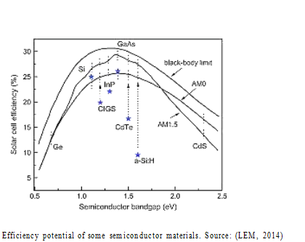

### Operation of Silicon Cells

SC is a junction of two types of materials, i.e. the n and p types of semiconductor materials. When those are joined together, free electrons in the n-type material move to the p-type material and also free holes from p-type material move to n-type material resembling the flow of electric charges, creating the so- called diffusion current (JD).

When the charge carriers (electrons and holes) move from one side to another, they leave behind both donor and accept-or ions on their previous material . Those left ions create spatial charges and, consequently there is an electric potential.

Where p is the electron concentration and the holes concentration, K- Boltzmann constant

(1.38 ∗ 10−23 𝐽 ), q- Electron charge (1.6 ∗ 10−19 𝑐) and T is the absolute temperature given in [0K]. As-electric field is gradient of electric potential,

𝐾

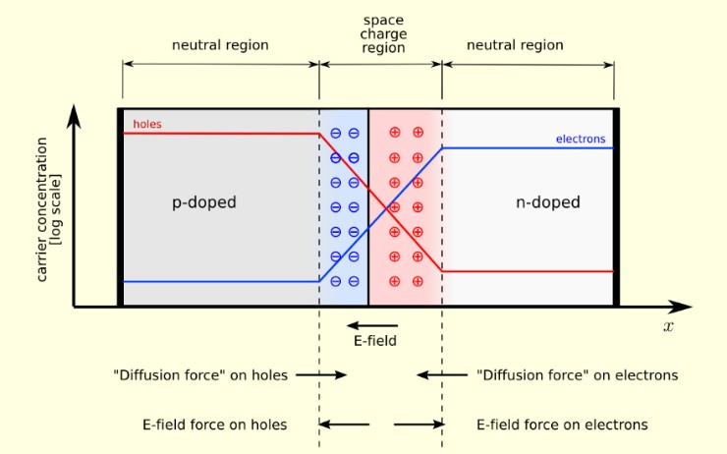

Figure 2. 2: P-N junction. Source:

The electric field due to the existence of spatial charges on a p-n junction, leads into the drift current  (“diffusion force” on holes) with opposite direction to the diffusion current (“diffusion force” on electrons). Thus, the appearance of drift current stops the diffusion of charge carriers from one side to another and the junction works as a dielectric as is shown in figure

more than *Eg*, after transferring this energy to the electron, it can jump into the conduction band and, due to electric dipole in depletion zone, electron can be directed to n-type material and the hole, to the p-type material.

The analysis of SC’s functionality can be stated using two models: the first is related with a single diode model and the second to two diode model. However for the next steps we’re revising the single diode model given that the second is more labour-intensive and is only used for full understanding of the behaviour of SC’s.

In the single diode model there are two modes of functioning of the SC’s, namely the ideal SC in which there are no crystal defects and, the second is related to the real SC in which crystal defects are taken into account.

* + - 1. The ideal SC is represented by a diode of three parameters: the short circuit current (Isc), the diode current (Id) and the current feeding the load (I).

In figure 2.4 below is presented a simplified diagram of an equivalent circuit of an ideal SC in which is taken into account that there is no voltage and current drop.

Figure 2. 4: Simplified diagram of an equivalent solar cell circuit

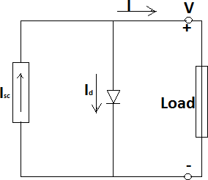

Applying the Kirchhoff’s law to the blue node of the equivalent SC in the figure above, the short circuit current is given by:

( )

The open circuit voltage 𝑉𝑜𝑐 and short circuit current 𝐼𝑠𝑐 are parameters given by the manufacturer and are very important to draw the I-V curve, given below (Figure 2.5), which is used to predict the SC’s performance at various temperatures, voltage loads and level of insolation.

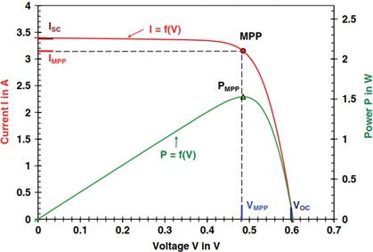Figure 2. 5: I-V and P-V curves of a solar cell. Source:

The main important point in this curve is MPP (maximal power point) that is the point in which the module produces the greatest power, it is always found where the curve begins to bend and defines the outputs of the module (VMPP – Voltage at maximum power point and IMPP – Current at maximum power point). The power output at any other point is less than the power at maximum power point (PMPP).

However, there is another parameter that describes the deviation of the I-V curve in relation to the ideal, called the Fill Factor (FF). The fill factor is the ratio of the maximum obtainable power to the product of the open-circuit voltage and short-circuit current.

The conversion efficiency (η) of SC, is the power density delivered at the operating point as a fraction of the incident light power density Ps and is given by the equation: 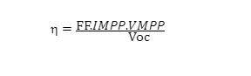

### The Real Solar Cell Model

The analysis of the real solar cell is made taking into account all cell defects namely, imperfection of semiconductor material defects, junction and metal contacts. These imperfections are clumped into Series Resistance (Rs) and Parallel resistance (Rp) shown in the figure 2.6 below.

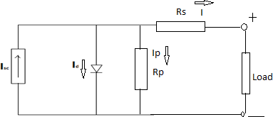Figure 2. 6: Simplified equivalent real solar cell

Taking into account the figure above the short circuit current (Isc) from equation number 3 and the current feeding the load can be transformed respectively to:

### 

### Factors that Influence the Operation of a Solar Module

There are five major factors that can affect the solar cell performance namely:

**a) The cell material:**

depending on the material and manufacturing method used, solar cells can achieve different conversion efficiencies of light, for instance the efficiency of amorphous silicon ranges from 5% to 7%, for the poly crystalline silicon, its efficiency does not exceed 12% and for the mono crystalline silicon the efficiency is over 12% and not exceeding 18% (Electronica, 2014) and (Seraphic, et al).

### 1.2.5 Solar panel circuit connections

The solar PV panels can be connected either in parallel or in series depending on the needs purposes. Connecting in series, the voltage is increased while the current remains constant, while connecting in parallel would keep the voltage constant but the current is increased. However these connections can be combined both in one single circuit (series-parallel) as shown in figure 2.8.

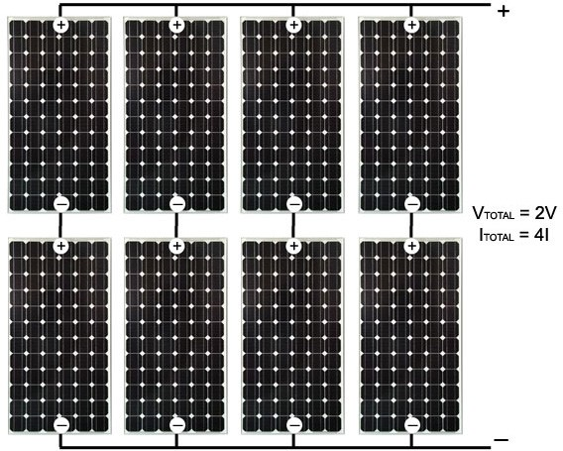

Figure 2.8: Connections of solar modules in

series-parallel The connections and results obtained from the solar panels are the same for Batteries connections.

**MPPT**

This section covers the theory and operation of "Maximum Power Point Tracking" as used in solar electric charge controllers.

An MPPT, or maximum power point tracker is an electronic DC to DC converter that optimizes the match between the solar array (PV panels), and the battery bank or utility grid. To put it simply, they convert a higher voltage DC output from solar panels (and a few wind generators) down to the lower voltage needed to charge batteries.

(These are sometimes called "power point trackers" for short - not to be confused with PANEL trackers, which are a solar panel mount that follows, or tracks, the sun).

.

**FUZZY LOGIC CONTROLLER:**

**INTRODUCTION:**

This is the first in a series of six articles intended to share information and experience in the realm of fuzzy logic (FL) and its application. This article will introduce FL. Through the course of this article series, a simple implementation will be explained in detail. Each article will include additional outside resource references for interested readers.

**WHERE DID FUZZY LOGIC COME FROM?**

                               The concept of Fuzzy Logic (FL) was conceived by Lotfi Zadeh, a professor at the University of California at Berkley, and presented not as a control methodology, but as a way of processing data by allowing partial set membership rather than crisp set membership or non-membership. This approach to set theory was not applied to control systems until the 70's due to insufficient small-computer capability prior to that time. Professor Zadeh reasoned that people do not require precise,

numerical information input, and yet they are capable of highly adaptive control. If feedback controllers could be programmed to accept noisy, imprecise input, they would be much more effective and perhaps easier to implement. Unfortunately, U.S. manufacturers have not been so quick to embrace this technology while the Europeans and Japanese have been aggressively building real products around it.

**WHAT IS FUZZY LOGIC CONTROLLER:**

                                  In this context, FL is a problem-solving control system methodology that lends itself to implementation in systems ranging from simple, small, embedded micro-controllers to large, networked, multi-channel PC or workstation-based data acquisition and control systems. It can be implemented in hardware, software, or a combination of both. FL provides a simple way to arrive at a definite conclusion based upon vague, ambiguous, imprecise, noisy, or missing input information. FL's approach to control problems mimics how a person would make decisions, only much faster.

**HOW DOES FUZZY LOGIC CONTROLLER WORK?**

                FL requires some numerical parameters in order to operate such as what is considered significant error and significant rate-of-change-of-error, but exact values of these numbers are usually not critical unless very responsive performance is required in which case empirical tuning would determine them. For example, a simple temperature control system could use a single temperature feedback sensor whose data is subtracted from the command signal to compute "error" and then time-differentiated to yield the error slope or rate-of-change-of-error, hereafter called "error-dot". Error might have units of degs F and a small error considered to be 2F while a large error is 5F. The "error-dot" might then have units of degs/min with a small error-dot being 5F/min and a large one being 15F/min.

               These values don't have to be symmetrical and can be "tweaked" once the system is operating in order to optimize performance. Generally, FL is so forgiving that the system will probably work the first time without any tweaking.FL was conceived as a better method for sorting and handling data but has proven to be a excellent choice for many control system applications since it mimics human control logic. It can be built into anything from small, hand-held products to large computerized process control systems. It uses an imprecise but very descriptive language to deal with input data more like a human operator. It is very robust and forgiving of operator and data input and often works when first implemented with little or no tuning

**WHY USE FAZZY LOGIC CONTROLLER:**

        FL offers several unique features that make it a particularly good choice for many control problems.

1) It is inherently robust since it does not require precise, noise-free inputs and can be programmed to fail safely if a feedback sensor quits or is destroyed. The output control is a smooth control function despite a wide range of input variations.

2) Since the FL controller processes user-defined rules governing the target control system, it can be modified and tweaked easily to improve or drastically alter system performance. New sensors can easily be incorporated into the system simply by generating appropriate governing rules.

3) FL is not limited to a few feedback inputs and one or two control outputs, nor is it necessary to measure or compute rate-of-change parameters in order for it to be implemented. Any sensor data that provides some indication of a system's actions and reactions is sufficient. This allows the sensors to be inexpensive and imprecise thus keeping the overall system cost and complexity low.

4) Because of the rule-based operation, any reasonable number of inputs can be processed (1-8 or more) and numerous outputs (1-4 or more) generated, although defining the rule base quickly becomes complex if too many inputs and outputs are chosen for a single implementation since rules defining their interrelations must also be defined. It would be better to break the control system into smaller chunks and use several smaller FL controllers distributed on the system, each with more limited responsibilities.

5) FL can control nonlinear systems that would be difficult or impossible to model mathematically. This opens doors for control systems that would normally be deemed unfeasible for automation.

Sources in Micro grid This paper establishes a mathematical model of the micro grid system based on the power output models of photovoltaic cells, wind turbines and storage batteries.

1) Mathematical model of photovoltaic cell power output In the micro grid, photovoltaic cells are generally controlled by MPPT, and the maximum output power is affected by the ambient temperature and light intensity. Generally use the following formula for approximate calculation:



where: is actual output power of photovoltaic cell; is the rated power under standard test conditions (light intensity ⁄ , ambient temperature ); is the actual light intensity; is the actual ambient temperature; is the power temperature coefficient, taking -0.47%. 2) Mathematical model of wind turbine power output The actual output power of a wind turbine is determined by the wind speed and the type of wind turbine. This paper uses linear model to approximate calculation, and the power output model is:

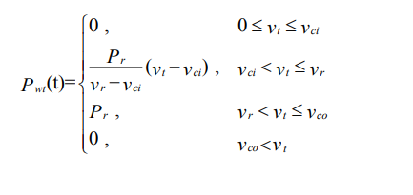

where: t Pwt is the actual power of the fan; vt is the actual wind speed; vci , v r and vco are the cut-in wind speed, rated wind speed and cut-out wind speed of the fan.

1. Mathematical Model of Battery State of Charge This article only considers the charge and discharge power of the battery and the remaining power, and mathematically model the battery from these two aspects.
2. During the discharge process, the state of charge at battery at time t is:



**BATTERY:**

Battery charge and discharge constraints In order to extend the service life of the battery as much as possible, it is necessary to prevent its over discharge and overcharge, so the state of charge and charge and discharge power of the battery are restricted. State-of-charge constraint:

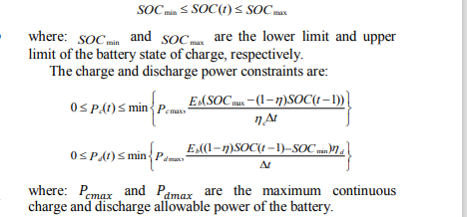

where: and are the maximum continuous charge and discharge allowable power of the battery.

### Types of Batteries

The rechargeable batteries can be either lead-acid, nickel-cadmium, nickel metal hydride, or lithium ion type for the ones being used commercially and in small scales. The lead acid batteries are most common for  solar/wind  power  systems  due  to  their  suitability,  availability  and  low  cost  compared  to  the  other types which are most used for small electric appliances such as radios and cell phones.

**Lead Acid Batteries:**

the basic principle of operation of lead-acid batteries is based on the reaction of lead plates coated with PbO2 (negative plates) that are connected to the positive connector (Pb) while the lead plates (positive plates) are connected to the negative connector. They are separated by a cardboard, plastic or some micro porous paper separator and then the assembly is placed in the battery compartment and dipped in an aqueous solution of sulfuric acid (H2SO2) as shown in the reaction equation below .

Pb + PbO2 + 2 H2SO4 ↔ 2 PbSO4 + 2 H2O (20)

According to Hawkins, 2010, the lead-acid batteries can be classified into two categories: the automotive battery (start-up battery) and the deep discharge (deep cycle) battery.

**Automotive batteries :**

THE designed to provide high current peaks for short periods, resulting in a small depth of discharge which is usually only 20% of the charge capability. This type of batteries are mostly used for engine starting, given that at the time of starting the starter of a vehicle’s engine consumes a lot of power for a short time. Batteries designed for peak current differ from the stationary deep-cycle ones by having more plates, but thinner .

**Deep discharge (deep cycle) :**

THESE batteries are designed to withstand discharges of up to 80% of their capacity, for instance absorbed glass mat (AGM), captive electrolyte gel and tubular plate batteries/OPZS or OPZV (wet or gel Cells) batteries.

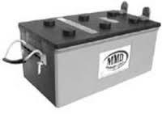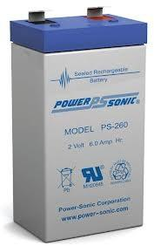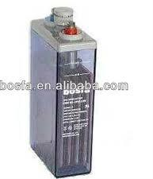

**Figure 2. 15:** Different types of deep discharge batteries, AGM (a); captive electrolyte gel

(b) and tubular plate batteries/OPZS or OPZV (c). Source: (PALSOLAR).

There are differences between the different deep-cycle battery modifications regarding architecture, prices in the market and number of life cycles; however, the most preferable is the last one in Figure 2.15 – the Tubular Plate type – due to its exceptionally long lifetime (900 to 1200 cycles) compared to any other lead-acid battery type (SEI).

**Key Battery Parameters and Characteristics:**

**Battery Voltage (V):**

The nominal voltage of a lead-acid battery is by definition **2.0 V** per cell; however, this voltage varies largely during charging and discharging, as a function of the current delivered or withdrawn, the elapsed time of loading or unloading, the temperature and constructive characteristics. During fast charging or if the battery is averaged, the voltage may reach 2.5 V per cell. During deep discharge, the voltage may drop to 1.6 V per cell, which is commonly regarded as a destructively low level.

### Battery capacity (C)

The battery capacity is usually defined in ampere-hours (Ah) and it is the amount of electricity that the battery is capable of providing under certain conditions, i.e., with given discharge current until a certain voltage level at a certain temperature. The battery capacity and discharge current are often indicated in conjunction with a subscript for discharge time in hours, i.e., C10 meaning battery capacity C for a discharge time of 10 h, is normally used to designate a battery’s nominal capacity and it is used as base for comparisons of different battery capacity data according to approximation below as C20 and C100 battery are the most useful for stand-alone systems.

**Approximate expression for nominal capacity:**

C10: C10 ~0.85 x C20 ~ 0.7 x C100

### Battery charge and discharge limit

If the battery is connected to the load, its voltage starts to decrease however if its nominal voltage becomes around 1.7 to 1.85 V, the battery must be disconnected from appliances in order to prevent a destructive depth of discharge (DOD) and enable long life span. If it is being charged and the voltage becomes higher than around 2.4 V, the battery has to be disconnected to prevent elevated gas formation (gassing)[3](https://docs.google.com/document/d/1DiDLBr1tL_CFcw5H39OumKWMWR2__yco/edit#heading=h.zu0gcz) (Haberlin).

### Life cycle versus depth of discharge

Life cycle is the number of cycles that a battery can carry out before its capacity reaches 80% of nominal capacity and it is basically determined by battery type and DOD. The higher the DOD, the shorter the life span for all types of batteries. It is advised that even deep cycle batteries should not be regularly discharged below 60% of  DOD (40% state of charge) .

Moreover, all types of batteries perform better at low currents rather than at high ones, both for charge and  discharge.  Slow  charge/discharge  procedures  prolong  the  life  span  of  any  battery  and  allow  for  a sustained high capacity level throughout the life cycle. Fast charging as well as fast discharge drawing high currents can easily lead to worse performance and shorter lifetime for any electo-chemical battery type.

# dspic microcontrollers introduction and features

**Three-phase Current Source Inverter**

The circuit of a Three-phase Current Source Inverter (CSI) is shown in Fig. 39.5a. The type of operation in this case is also same here, i.e. Auto-Sequential Commutated Inverter (ASCI). As in the circuit of a single-phase CSI, the input is also a constant current source. The output current (phase) waveforms are shown in Fig. 39.5b. In this circuit, six thyristors, two in each of three arms, are used, as in a three-phase VSI. Also, six diodes, each one in series with the respective thyristor, are needed here, as used for single-phase CSI. Six capacitors, three each in two (top and bottom) halves, are used for commutation. It may be noted that six capacitors are equal, i.e. . The diodes are needed in CSI, so as to prevent the capacitors from discharging into the load. The numbering scheme for the thyristors and diodes are same, as used in a three-phase VSI, with the thyristors being triggered in sequence as per number assigned (Fig. 39.5b).

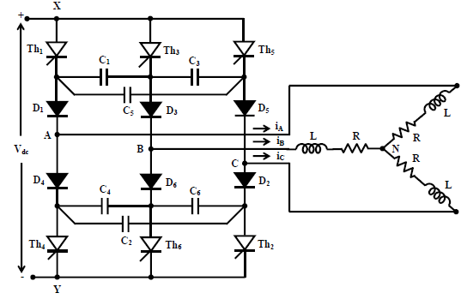

Fig. 39.5(A): Three-phase CSI

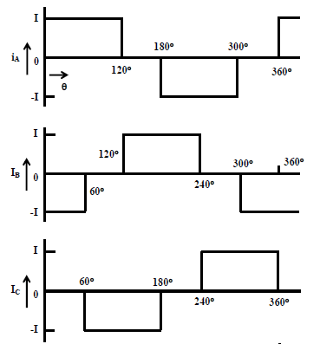

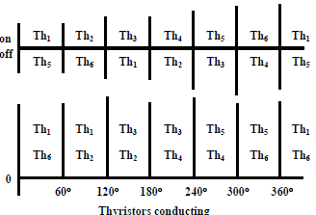

Fig. 39.5(b): Phase current waveforms

The commutation process in a three-phase CSI is described in brief. The circuit, when two thyristors, Th1 & Th2, and the respective diodes, are conducting, is shown in Fig. 39.6a. The current is flowing in two phases, A & C. The three capacitors in the top half, are charged previously, or have to pre-charged as shown. But the capacitors in the bottom half are not shown.

**Mode I:** The commutation process starts, when the thyristor, Th3 in the top half, is triggered, i.e. pulse is fed at its gate. Immediately after this, the conducting thyristor, Th1 turns off by the application of reverse voltage of the equivalent capacitor. Mode I (Fig. 39.6b) now starts. As the diode D1 is still conducting, the current path is via Th3, the equivalent capacitor, D1, and the load in phase A (only in the top half). The other part, i.e. the bottom half and the source, is not considered here, as the path there remains same. The current, I from the source now flows in the reverse direction, thus the voltage in the capacitor, C1 (and also the other two) decreases. It may be noted the equivalent capacitor is the parallel combination of the capacitor, C1 and the other part, being the series combination of the capacitors, C3 & C5. It may be shown the its value. Also, the current in the capacitor, C1 is , and the current in other two capacitors, CI⋅)3/2(3 & C5 is . When the voltage across the capacitor, C3/I1 (and also the other two) decreases to zero, the mode I ends.

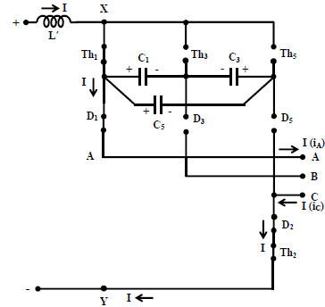

Fig. 39.6(a): Three-phase CSI with two thyristors, Th1 & Th2 conducting

**Mode II:** After the end of mode I, the voltage across the diode, D3 goes positive, as the voltage across the equivalent capacitor goes negative, assuming that initially (start of mode I) the voltage was positive. It may be noted that the current through the equivalent capacitor continues to flow in the same direction. Mode II (Fig. 39.6c) starts. Earlier, the diode, D1 was conducting. The diode, D3 now starts conducting, with the voltage across it being positive as given earlier. A circulating current path now exists between the equivalent capacitor, two conducting diodes, D1 & D3 and the load (assumed to be inductive − R & L, per phase) of the two phases, A & B, the two loads and also the two diodes being now connected in series across the equivalent capacitor. The current in this path is oscillatory, and goes to zero after some time, when the mode II ends. The diode, D1 turns off, as the current goes to zero. So, at the end of mode II, the thyristor, Th3 & the diode, D3 conduct. This process has been described in detail in the earlier section on single-phase CSI (see mode II). It may be noted that the polarity of the voltage across the equivalent capacitor (at the end of mode II) has reversed from the initial voltage (at the beginning of mode I). This is needed to turn off the outgoing (conducting) thyristor, Th3, when the incoming thyristor, Th5 is triggered. The complete commutation process as described will be repeated. The diodes in the circuit prevent the voltage across the capacitors discharging through the load.

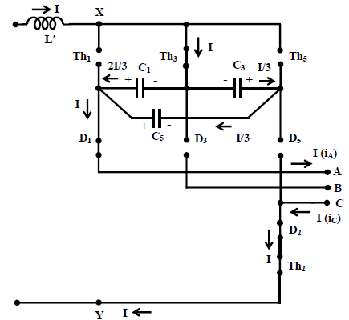

Fig. 39.6(b): Mode I (3-phase CSI)

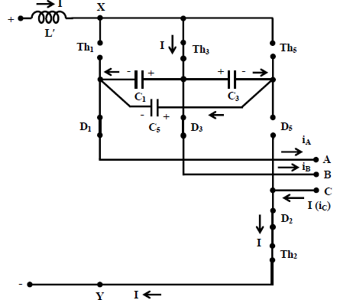

Fig. 39.6(c): Mode II (3-phase CSI)

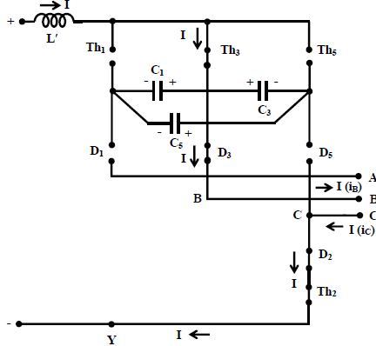

Fig. 39.6(d): Three-phase CSI with two thyristors, Th3 & Th2 conducting

**INTRODUCTION OF dsPIC DIGITAL SIGNAL CONTROLLER**

This article contains an introductory note at**dsPIC**as well as learn more about the features of this proficient digital signal controller. In 2001, Microchip introduced the **dsPIC** series of chips, which penetrated mass production later.They are Microchip’s first innately 16-bit micro controllers. It is supported by embedded code.PIC24 devices are just designed as general function micro-controllers. **dsPIC** devices include digital signal processing (DSP) proficiency  in addition.The**dsPIC** is a 16-bit micro controller with high-performance and the high computation speed of a fully implemented digital signal processor (DSP).It is for signal conditioning too. There are some features and motor control facility and peripherals in dsPIC to facilitate control applications and signal processing.[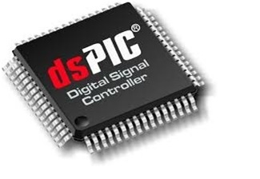](https://microcontrollerslab.com/wp-content/uploads/2017/08/dspic-microcontrollers-introduction.jpg)

### Introduction to dSPIC based DSC (Digital Signal Controller)

A Digital Signal Controller is a single-chip that flawlessly combines the control features of a Microcontroller (MCU) with the computation and throughput aptitudes of a Digital Signal Processor (DSP) just in a single core. Microchip’s dsPICR DSC offers you everything which would be expected from a powerful 16-bit MCU: sophisticated, fast and flexible interrupt handling; a wide array of analog and digital peripheral functions; flexible clocking options; power management; brown-out protection; power-on-reset; full-speed real-time emulation;  code security; watchdog timer and full-speed in-circuit debug solutions.

By proficiently adding DSP capabilities to a high-performance 16-bit MCU.The dsPIC30F is an advanced 16-bit processor that offers accurate DSP capabilities with the fundamental real-time control proficiencies of a microcontroller.Extensive built-in peripherals, prioritize interrupts and power management features are joind with a full-featured DSP engine. Single-cycle 16×16 MAC, dual 40-bit accumulators, dual-operand fetches, 40-bit barrel shifter and zero-overhead looping are among the attributes that make this a very proficient DSC.

**Special Features of dspic microcontrollers**

* **Flexible Flash:**The dsPIC30F and dsPIC33F both make use of flexible and secure Flash memory. The dsPIC DSC Flash is used to store programs or data tables. All dsPIC DSCs can firmly self-program their own flash in a finished product.
* **Add DSP:**Adding a DSP chip in existing MCU-based system is complicated and costly. The dsPIC30F and the dsPIC33F are designed to feel and look like MCUs. Adding DSP functionalities in the familiar controller like environment can be completed easily.
* **Powerful 16-bit MCU:**The dsPIC30F and dsPIC33F families of digital signal controllers (DSC) execute most of the instructions in 1 cycle. It combines high instruction throughput with DSP capabilities, such as zero overhead looping and single cycle 16-bit multiply .

### Architecture of dspic microcontrollers

**Harvard Architecture**

The dsPIC processor (DSP) uses Harvard architecture with separate program and data memory buses, as shown in Figure                                                                                                                                             **Separate Data and Program Buses**

This is an ability of Harvard architecture that it permits different size data (16 bits) and instruction (24 bits) words. This modified design improves the effectiveness of the instruction set. It also permits faster processing because the dsPIC processor (DSP) can pre-fetch the next instruction from program memory while it is executing the current instruction which accesses data RAM.

### [IMG_258](https://microcontrollerslab.com/wp-content/uploads/2017/08/dspic-microcontrollers-architecture.jpg)Program Memory and Program Counter of dspic

The Program Counter (PC) is 24 bits wide and it addresses up to 4M x 24 bits of user program memory space. The Program Counter can increments by 2 for each 24-bit instruction, which makes simpler the addressing of 16-bit data stored in program memory. Program memory space contains the Interrupt Vector Tables,Reset location, data EEPROM, user program memory and configuration memory.

The processor starts a program from the Reset location 0x000000. Program memory for the code initiates after the vector tables at address 0x100.

 It should be user-programmed with GOTO instructions. The GOTO instructions at the Reset location are always followed by the Interrupt Vector Tables. Program looping is completed with least overhead with the DO and REPEAT

Instructions. These attributes make repetitive DSP algorithms very efficient while keeping up the talent to handle real-time events.

### Data Addressing Modes of dspic

The CPU supports Relative, Memory Direct, Literal, Register Direct and Register Indirect Addressing modes. Each instruction that addresses data memory can use some of the available addressing modes and almost 6 addressing modes are available to support each instruction. The working registers are used widely as address pointers for the indirect addressing modes. They can be modified or incremented and used as pointers in the same instruction.

### DSP Engine

The features of DSP engine are high-speed, multiplier, 17-bit x 17-bit fixed-point, a 40-bit ALU (Arithmetic Logic Unit), a 40-bit bidirectional barrel shifter and two 40-bit saturating accumulators. In it, barrel shifter has capability of shifting a 40-bit value up to 15 bits right or may up to 16 bits left, in one single cycle.The DSP instructions operate with all other instructions seamlessly and have been accurately designed for most favourable real-time performance. The MAC and other associated instructions concurrently fetch two data operands from memory at the time of multiplying two W registers.

## Peripherals of dspic microcontrollers

These devices (dsPIC) are obtainable with a wide range of peripherals. The main peripherals include:

I/O Ports                                                         10-bit or 12-bit A/D Converter

Output Compare/PWM                                I2C.

 Timers                                                            UART

 Input Capture                                               SPI.

Motor Control PWM                                     Data Converter (CODEC)Interface

Controller Area Network (CAN)                     Quadrature Encoder

### Interrupts of dspic microcontrollers

The dsPIC30F has a vectored interrupt system. Each interrupt has its own vector and can be assigned one of seven priority levels. Each interrupt vector contains starting address 24bit wide of the associated Interrupt Service Routine (ISR).The interrupt entry and return latencies are always providing deterministic timing for real-time applications and fixed. The Interrupt Vector Table (IVT) exists in program memory.The Interrupt Vector Table ( IVT) contains 62 vectors containing up to 8 non-mark able error trap vectors and up to 55 sources of the interrupt.

**Driver circuit board**

There are several different ways of controlling speeds of DC motors. However, one of the most preferred and simple ways is by using Pulse Width Modulation (PWM). The [PWM](https://en.wikipedia.org/wiki/Pulse-width_modulation) (Pulse Width Modulation) is a technique used in driving inertial loads for a long time. The use of [pulse width modulation in controlling motor drivers](https://www.wellpcb.com/capabilities.html#Capabilities) comes with several advantages.

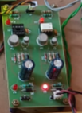

But perhaps, the most significant advantage is that since the transistor is either fully [“OFF” or “ON,”](https://www.electronics-tutorials.ws/blog/pulse-width-modulation.html) the power loss in the switching conductor remains small. This article discusses how to go about designing a PWM circuit. Here, there will be a discussion of important issues, such as effectively cutting electric signals into discrete

**CONTROL STRATEGY FOR OPTIMAL CONFIGURATION OF MICROGRID CAPACITY**

For the structure of the proposed microgrid, this paper aims to ensure the real-time power balance on both AC and DC sides, maximize the use of new energy to generate electricity, reduce battery charge and discharge times, increase service life, reduce the power loss of the converter between AC and DC buses and increase Self-balance rate on both sides of DC. Based on the power balance relationship between AC and DC power generation and load, a reasonable operation control strategy is proposed in this section to coordinate the output of various distributed power sources, control the power flow, and reduce the economic cost of microgrid operation. The control strategy is as follows:

1. The power output of the distributed power supply on the AC side and the DC side both meet the demand of the load. The battery is charged to absorb the excess power. If the remaining power exceeds the battery's maximum charging limit, the excess power is sold to the grid. If the power limit is exceeded, the excess power becomes waste.
2. The power output of the AC-side distributed power supply meets the demand of the load, and the power output of the DC-side distributed power supply does not meet the demand of the load. The excess power on the AC side is provided to the DC side to fill the DC side power shortage, and the excess electric energy is absorbed by the battery. If the AC side power is surplus after meeting the DC side power shortage, and the battery cannot absorb all the excess power, then sells electricity to the grid, the part that exceeds the power limit for sale becomes a curtailment. If the remaining power on the AC side cannot meet the power shortage on the DC side, the battery discharges to provide the required power, and the shortfall is made up by the grid

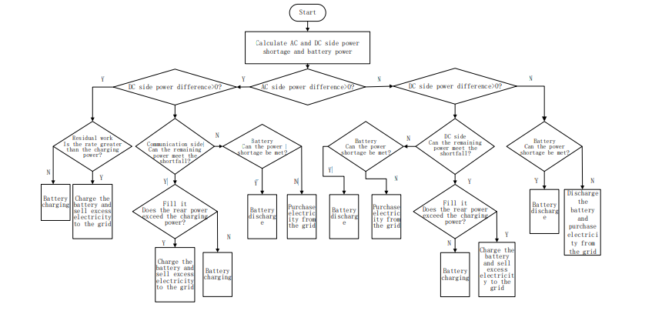  
 FIG:Control strategy of micro grid

## Inverters and Charge Controllers

Inverters are devices used to convert the DC electrical current into AC and vice versa. The inverters can be classified according to their waveform: square wave, modified square wave and sine wave (SEI).

The **square wave inverters** have a very weak control voltage output and a high harmonic distortion, hence they are not suitable for residential use in spite of having the lowest costs on the market. The **modified square wave inverters**, are coupled with some electronic devices (field effect transistors – FET or Silicon controlled rectifiers -SCR) which enable them to reduce the harmonic distortion presented by the first type. However, certain residential equipment cannot be connected to this type of inverters either. **Sine Wave Inverters** - are the most advanced and appropriate for residential electrification purposes, since they provide an output signal with low harmonic distortion. That fact allows them to supply electricity even to any equipment, including sensitive devices (SEI).

Gassing is the process of destructive gas generation in batteries when they are overcharged

Charge controllers are electrical circuits used to control the state of charge of the batteries. These devices work as an enter key, allowing the current to flow into the batteries when it is charged and close the current flow when the batteries are fully charged in order to prevent overcharge as referred in the section

2.3.2 c) above. In most cases the controllers are coupled into inverters (Hawkins).

The power output of the distributed power supply on the AC side cannot meet the demand of the load, and the power output of the distributed power supply on the DC side meets the demand of the load. When there is less shortage on the AC side, the excess power on the DC side is used to compensate the AC side, and the battery absorbs the excess power on the DC side. If the power limit of the battery is exceeded, power is sold to the grid. If the remaining power on the DC side cannot meet the power shortage on the AC side, the battery discharges to compensate. If it still does not meet, the grid will compensate. (4) The power output of distributed power sources on both AC and DC sides cannot meet the load demand. The battery discharges to fill the power gap. If it cannot be satisfied, the grid will compensate. From the above control strategy, the flow chart of the operation control strategy of the microgrid can be obtained as shown in Figure 2.

**THE OPTIMAL SCHEME OF MICROGRID CAPACITY CONFIGURATION**

According to the actual climate and load data of a certain area in the past year, the genetic algorithm is used to optimize its capacity allocation. And then the self-balance rate is used as the main evaluation index of the microgrid economy to select 573 Authorized licensed use limited to: Western Sydney University. Downloaded on June 15,2021 at 12:35:14 UTC from IEEE Xplore. Restrictions apply. the optimal configuration of the microgrid. The effectiveness of the capacity optimization configuration control strategy proposed in this paper is demonstrated. The cost of installation and maintenance, power supply capacity and inverter cost of each distributed power supply are shown in Table I.

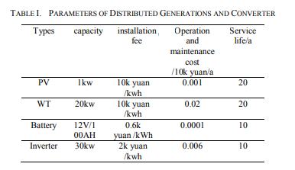

The cut-in wind speed vci is 2m s . The cut-out wind speed vco is 18m s . The rated wind speed v r is 11m s . The initial state of charge of the battery SOC=0.5, the state of charge is limited to SOC min  0.1 , SOC max  0.9 and the charge-discharge efficiency is 0.9.Using the power model of the power supply, the effect of peak shaving and valley filling of the microgrid and its economic benefits are not considered. The price of electricity purchased and sold by the microgrid is fixed in order to simplify the calculation. The electricity purchase price is 0.7660 , the electricity sale price is 0.60 yuan/kW∙h. The maximum value of energy waste rate is set to 15%.The maximum load of the microgrid is 300kW, and the maximum power transmission between the grid and the distribution network is 90kW. In order to simulate the proportion of AC and DC load，the DC load ratio of the load is 40%, and the AC load ratio is 60%. The conversion efficiency of the converter between AC and DC buses is 95%.The maximum energy waste rate is set to 5% in order to ensure the utilization of installed equipment. The annual data curve of environment and load is shown in Figure 3: temperature/ th/ Light intensity/ 2 m.

## Evaluation of Solar Energy

Solar or Wind power generation does not supply electricity to the load continuously, due to its intermittent character preventing it from meeting a steady constant demand at different times. Therefore, both sources need to be considered as variable forms of energy output. Their separate utilization should always account for the variability and unpredictability of the resource.

One way to minimize the influence of intermittency of wind and solar sources is to combine the two sources into one system so that the unavailability of one of them can be compensated by the activity of another. This combination leads to hybrid configurations, which are the focus of the present study.

### Electricity Supply Through SOLAR Power Systems

SOLAR power systems are basically those systems that consist of two or more energy sources for power generation, and can be conventional or not such as generation by wind, solar PV, natural gas, diesel oil, bio-fuel among others, with the goal of providing electricity or co-generation, either stand-alone or connected to the grid. Those systems are complex and require the optimization of energy control and use of all sources in order to get the maximum efficiency on the delivery of energy to the consumer units, maintaining the quality and reliability specified for each proposed project.

Within this present study, an isolated solar system for electricity generation and a mini-grid to distribute the generated electricity to a small load are proposed. Figure 2.16 illustrates the schematic example of a hybrid system configuration of this type.

**Figure 2. 16:** Stand-alone hybrid system schematic configuration with AC energy bus:

* Charge controller/bidirectional inverter;
* Solar PV panels;
* Battery bank;
* Grid Inverter;

 AC appliances. Source: (BCS).

The system combines solar photovoltaic panels that produce electricity in DC and wind turbines, which can produce electricity either in DC or AC. To associate these sources of electricity to a load and battery bank, whose current is continuous (DC), the system needs a power converter that can ensure that current flows between the different equipment and provides to the load indicated by “6” in the figure above.

**Complementary between sources of the system:** intermittency of sources involved can be partially or completely overcome, ensuring continuity and quality of the electricity produced by the system;

**Molecularity of the involved sources:** photovoltaic modules, turbines, and batteries can be purchased gradually of the system, provided there is natural growth of the system in line with the availability of financial resources, energy potential and area for the system installation;

**The socioeconomic impacts:** in general, are characterized as products for the deployment of hybrid systems. In most instances the impacts have more beneficial features than harmful, especially when treating with small generation systems as is proposed in the present work. It is also noted the Rural population growth, because it can combat the rural exodus, the increase of local commercial activities (bars, warehouses), agriculture, education and telecommunication, which is made possible by the wider use of electricity;

As **for environmental impacts,** they are primarily related to the end-of-life issues and recycling of the used equipment, primarily the management of batteries (there is a need for a recycling program); to the visual and noise aspect from the rotation of the wind turbines blades, and occupation of space used for eq

equipment installation of the hybrid system. Hybrid systems may represent a viable alternative for technical, financial, social and environmental criteria, including advantages with regard to the extension of the power grid or the local power generation by diesel systems.

## The Local Study Area (Mozambique)

## 2.Geographical Location and Climate

.Mozambique is located on the Eastern African coast side of the southern African subcontinent, facing the Indian Ocean between latitudes 10º 27´S and 26º 52´S and b e t w e e n longitudes 30º 12´E and

40º 51´E, and has a long coastline of about 2, 515 km with continental shelf area of approximately 68,000 km2 (INE, 2007). Figure 2.17 illustrates the Map of Mozambique and its regional division.

Its climate is characterized by two typical climate seasons: the wet season, which extends from October to April and is hot and rainy; and the dry season, which is a kind of a cooler winter from May to October with very limited rain. The annual mean temperature vary from the northern to the southern region and from the coast to the highlands in the interior of the country. The coastal plain has a tropical humid to sub humid climate with a mean temperature of about 24ºC in the southern region and 25°C in the northern region (Zucule).

## Mozambique Energy Profile

Mozambique is rich in energy resources (fossil and renewable) not exploited yet: namely natural gas and coal, solar, wind, hydro, geothermal, ocean and biomass. According to Hawkins9, it is estimated that the renewable sources are as large as presented in the Renewable Energy Resources in Mozambique

The available mapping of the distribution and potential of the solar and wind resources in the country are presented in the next section.

### Solar Radiation and Distribution and its Potential

**Solar Radiation Resource:**

Mozambique has great unexploited solar radiation potential. According to Cuamba (2006), the availability of solar radiation across the country, varies between 5.2 and 6 kWh/m2/day with the annual daily average of 5.7 kWh/m2/day. However the most recent studies done by FUNAE, confirm that in Mozambique the global horizontal irradiation varies between 1.785 and 2.206 kWh/m2/year and the solar potential is 23 TWp (FUNAE, 2014). Figure 2.18 below shows the solar radiation distribution in Mozambique.

# DC TO DC CONVERTER

In electronics engineering, a DC to DC converter is a circuit which converts a source of direct current from one voltage to another. It is a class of power converter.

DC to DC converters are important in portable electronic devices such as cellular phones and laptop computers, which are supplied with power from batteries. Such electronic devices often contain several sub-circuits with each sub-circuit requiring a unique voltage level different than that supplied by the battery (sometimes higher or lower than the battery voltage, and possibly even negative voltage). Additionally, the battery voltage declines as its stored power is drained. DC to DC converters offer a method of generating multiple controlled voltages from a single variable battery voltage, thereby saving space instead of using multiple batteries to supply different parts of the device.

**Conversion methods**

Linear A simple method of converting one voltage to another is a circuit known as a voltage divider. This technique uses resistors in series with the voltage supply to provide a lower voltage. However, this method suffers serious drawbacks:

* Provides no voltage regulation
* Requires knowledge of the resistance of the load
* Poor efficiency, which also leads to excess heat dissipation
* Impossible to generate voltages higher than the supply voltage
* Impossible to generate negative voltages, unless the system ground is defined by a node in the resistor network.

Any kind of voltage regulator solves the first two problems, however, linear regulators still have the last three problems.

**Switched-mode conversion**

Electronic switch-mode DC to DC converters are available to convert one DC voltage level to another. These circuits, very similar to a switched-mode power supply, generally perform the conversion by applying a DC voltage across an inductor or transformer for a period of time (usually in the 100 kHz to 5 MHz range) which causes current to flow through it and store energy magnetically, then switching this voltage off and causing the stored energy to be transferred to the voltage output in a controlled manner. By adjusting the ratio of on/off time, the output voltage can be regulated even as the current demand changes. This conversion method is more power efficient (often 80% to 95%) than linear voltage conversion which must dissipate unwanted power. This efficiency is beneficial to increasing the running time of battery operated devices. A drawback to switching converters is the electronic noise they generate at high frequencies, which must sometimes be filtered.

Isolated DC-DC converters convert a DC input power source to a DC output power while maintaining isolation between the input and the output, generally allowing differences in the input-output ground potentials in the range of hundreds or thousands of volts. They can be an exception to the definition of DC-DC converters in that their output voltage is often (but not always) the same as the input voltage.

A current-output DC-DC converter accepts a DC power input, and produces as its output a constant current, while the output voltage depends on the impedance of the load. The various topologies of the DC to DC converter can generate voltages higher, lower, higher and lower or negative of the input voltage; their names are:

* Buck
* Boost
* Luo
* Ćuk

In general, the term "DC to DC converter" almost always refers to one of these switching converters.

Switching DC to DC converters are available in a wide variety of input and fixed or adjustable output voltages.

DC to DC converters are now available as integrated circuits needing minimal extra components to build a complete converter. DC to DC converters are also available as complete hybrid circuits, ready for use within an electronic device.

## DC-DC CONVERTER BASICS

A DC-to-DC converter is a device that accepts a DC input voltage and produces a DC output voltage. Typically the output produced is at a different voltage level than the input. In addition, DC-to-DC converters are used to provide noise isolation, power bus regulation, etc. This is a summary of some of the popular DC-to-DC converter topolopgies:

## BOOST CONVERTER STEP-UP CONVERTER

The schematic in Fig. 6 shows the basic boost converter. This circuit is used when a higher output voltage than input is required.

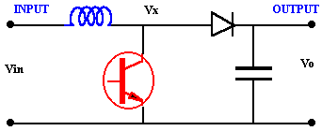

Boost Converter Circuit

While the transistor is ON Vx =Vin, and the OFF state the inductor current flows through the diode giving Vx =Vo. For this analysis it is assumed that the inductor current always remains flowing (continuous conduction). The voltage across the inductor and the average must be zero for the average current to remain in steady state

picture

This can be rearranged as

picture

and for a lossless circuit the power balance ensures

picture

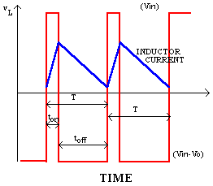

Voltage and current waveforms (Boost Converter)

# Since the duty ratio "D" is between 0 and 1 the output voltage must always be higher than the input voltage in magnitude. The negative sign indicates a reversal of sense of the output voltage.

A **boost converter** (**step-up converter**) is a [power converter](http://en.wikipedia.org/wiki/Power_converter) with an output DC voltage greater than its input DC voltage. It is a class of [switching-mode power supply (SMPS)](http://en.wikipedia.org/wiki/Switched-mode_power_supply) containing at least two [semiconductor](http://en.wikipedia.org/wiki/Semiconductor) switches (a [diode](http://en.wikipedia.org/wiki/Diode) and a [transistor](http://en.wikipedia.org/wiki/Transistor)) and at least one [energy](http://en.wikipedia.org/wiki/Energy) storage element. Filters made of [capacitors](http://en.wikipedia.org/wiki/Capacitor) (sometimes in combination with [inductors](http://en.wikipedia.org/wiki/Inductor)) are normally added to the output of the converter to reduce output voltage ripple.

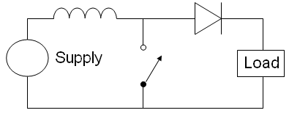

## Overview

Power can also come from DC sources such as batteries, solar panels, rectifiers and DC generators. A process that changes one DC voltage to a different DC voltage is called DC to DC conversion. A boost converter is a [DC to DC converter](http://en.wikipedia.org/wiki/DC_to_DC_converter) with an output voltage greater than the source voltage. A boost converter is sometimes called a step-up converter since it “steps up” the source voltage. Since power (P = VI) [must be conserved](http://en.wikipedia.org/wiki/Law_of_conservation_of_energy), the output current is lower than the source current.

A boost converter may also be referred to as a '[Joule thief](http://en.wikipedia.org/wiki/Joule_thief)'. This term is usually used only with very low power battery applications, and is aimed at the ability of a boost converter to 'steal' the remaining energy in a battery. This energy would otherwise be wasted since a normal load wouldn't be able to handle the battery's low voltage.

## History

For high efficiency, the [SMPS](http://en.wikipedia.org/wiki/Switched-mode_power_supply) switch must turn on and off quickly and have low losses. The advent of a commercial [semiconductor](http://en.wikipedia.org/wiki/Semiconductor) switch in the 1950’s represented a major milestone that made SMPSs such as the boost converter possible. Semiconductor switches turned on and off more quickly and lasted longer than other switches such as [vacuum tubes](http://en.wikipedia.org/wiki/Vacuum_tube) and electromechanical relays. The major [DC to DC converters](http://en.wikipedia.org/wiki/DC_to_DC_converter) were developed in the early 1960s when semiconductor switches had become available. The [aerospace](http://en.wikipedia.org/wiki/Aerospace) industry’s need for small, lightweight, and efficient power converters led to the converter’s rapid development.

Switched systems such as SMPS are a challenge to design since its model depends on whether a switch is opened or closed. R.D. Middle brook from [Caltech](http://en.wikipedia.org/wiki/Caltech) in 1977 published the models for DC to DC converters used today. Middle brook averaged the circuit configurations for each switch state in a technique called state-space averaging. This simplification reduced two systems into one. The new model led to insightful design equations which helped SMPS growth.

## Applications

Battery powered systems often stack cells in series to achieve higher voltage. However, sufficient stacking of cells is not possible in many high voltage applications due to lack of space. Boost converters can increase the voltage and reduce the number of cells. Two battery-powered applications that use boost converters are [hybrid electric vehicles](http://en.wikipedia.org/wiki/Hybrid_vehicle) (HEV) and lighting systems.

The [Toyota Prius](http://en.wikipedia.org/wiki/Toyota_Prius) HEV uses a 500 V motor. Without a boost converter, the Prius would need nearly 417 cells to power the motor. However, a Prius actually uses only 168 cells and boosts the battery voltage from 202 V to 500 V. Boost converters also power devices at smaller scale applications, such as portable lighting systems. A [white LED](http://en.wikipedia.org/wiki/LED#Ultraviolet.2C_Blue_and_white_LEDs) typically requires 3.3 V to emit light, and a boost converter can step up the voltage from a single 1.5 V alkaline cell to power the lamp. Boost converters can also produce higher voltages to operate [cold cathode](http://en.wikipedia.org/wiki/Cold_cathode) fluorescent tubes (CCFL) in devices such as [LCD](http://en.wikipedia.org/wiki/Liquid_crystal_display) [backlights](http://en.wikipedia.org/wiki/Backlight) and some [flashlights](http://en.wikipedia.org/wiki/Flashlight).

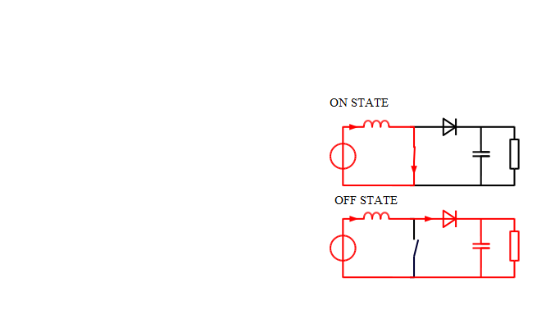

## Circuit analysis

### Operating principle

The key principle that drives the boost converter is the tendency of an inductor to resist changes in current. When being charged it acts as a load and absorbs energy (somewhat like a resistor), when being discharged, it acts as an energy source (somewhat like a battery). The voltage it produces during the discharge phase is related to the rate of change of current, and not to the original charging voltage, thus allowing different input and output voltages.

[[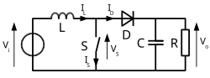](http://en.wikipedia.org/wiki/File:Boost_conventions.svg)](http://en.wikipedia.org/wiki/File:Boost_conventions.svg)Boost converter schematic

The two configurations of a boost converter, depending on the state of the switch S.

The basic principle of a Boost converter consists of 2 distinct states (see figure 2):

* In the On-state, the switch S (see figure 1) is closed, resulting in an increase in the inductor current;
* In the Off-state, the switch is open and the only path offered to inductor current is through the [flyback diode](http://en.wikipedia.org/wiki/Flyback_diode) D, the capacitor C and the load R. This results in transferring the energy accumulated during the On-state into the capacitor.
* The input current is the same as the inductor current as can be seen in figure 2. So it is not discontinuous as in the [buck converter](http://en.wikipedia.org/wiki/Buck_converter) and the requirements on the input filter are relaxed compared to a [buck converter](http://en.wikipedia.org/wiki/Buck_converter).

Continuous mode

[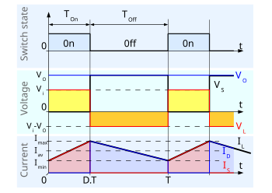](http://en.wikipedia.org/wiki/File:Boost_chronogram.svg)

Waveforms of current and voltage in a boost converter operating in continuous mode.

When a boost converter operates in continuous mode, the current through the inductor (IL) never falls to zero. Figure 3 shows the typical waveforms of currents and voltages in a converter operating in this mode. The output voltage can be calculated as follows, in the case of an ideal converter (i.e. using components with an ideal behaviour) operating in steady conditions:

During the On-state, the switch S is closed, which makes the input voltage (Vi) appear across the inductor, which causes a change in current (IL) flowing through the inductor during a time period (t) by the formula:

\frac{\Delta I_L}{\Delta t}=\frac{V_i}{L}

At the end of the On-state, the increase of IL is therefore:

\Delta I_{L_{On}}=\frac{1}{L}\int_0^{D T}V_i d t=\frac{D T}{L} V_i

D is the duty cycle. It represents the fraction of the commutation period T during which the switch is On. Therefore D ranges between 0 (S is never on) and 1 (S is always on).

During the Off-state, the switch S is open, so the inductor current flows through the load. If we consider zero voltage drop in the diode, and a capacitor large enough for its voltage to remain constant, the evolution of IL is:

V_i-V_o=L\frac{dI_L}{dt}  
Therefore, the variation of IL during the Off-period is:

\Delta I_{L_{Off}}=\int_0^{\left(1-D\right) T}\frac{\left(V_i-V_o\right) dt}{L}=\frac{\left(V_i-V_o\right) \left(1-D\right) T}{L}As we consider that the converter operates in steady-state conditions, the amount of energy stored in each of its components has to be the same at the beginning and at the end of a commutation cycle. In particular, the energy stored in the inductor is given by:

E=\frac{1}{2} L I_L^2

So, the inductor current has to be the same at the start and end of the commutation cycle. This means the overall change in the current (the sum of the changes) is zero:

This can be written as:

\frac{V_o}{V_i}=\frac{1}{1-D}

Which in turns reveals the duty cycle to be:

D={1-\frac{V_i}{V_o}}

From the above expression it can be seen that the output voltage is always higher than the input voltage (as the duty cycle goes from 0 to 1), and that it increases with D, theoretically to infinity as D approaches 1. This is why this converter is sometimes referred to as a step-up converter.

#### Discontinuous mode

[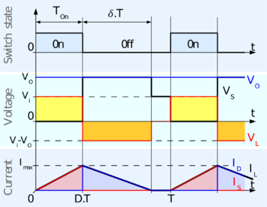](http://en.wikipedia.org/wiki/File:Boost_chronogram_discontinuous.png)

Waveforms of current and voltage in a boost converter operating in discontinuous mode.

In some cases, the amount of energy required by the load is small enough to be transferred in a time smaller than the whole commutation period. In this case, the current through the inductor falls to zero during part of the period. The only difference in the principle described above is that the inductor is completely discharged at the end of the commutation cycle (see waveforms in figure 4). Although slight, the difference has a strong effect on the output voltage equation. It can be calculated as follows:

As the inductor current at the beginning of the cycle is zero, its maximum value (at t = DT) is

I_{L_{Max}}=\frac{V_i D T}{L}

During the off-period, IL falls to zero after δT:

I_{L_{Max}}+\frac{\left(V_i-V_o\right) \delta T}{L}=0

Using the two previous equations, δ is:

\delta=\frac{V_i D}{V_o-V_i}

The load current Io is equal to the average diode current (ID). As can be seen on figure 4, the diode current is equal to the inductor current during the off-state. Therefore the output current can be written as:

I_o=\bar{I_D}=\frac{I_{L_{max}}}{2}\delta  
Replacing ILmax and δ by their respective expressions yields:

I_o=\frac{V_i D T}{2L}\cdot\frac{V_i D}{V_o-V_i}=\frac{V_i^2 D^2 T}{2L\left(V_o-V_i\right)}Therefore, the output voltage gain can be written as flow:

\frac{V_o}{V_i}=1+\frac{V_i D^2 T}{2L I_o}

Compared to the expression of the output voltage for the continuous mode, this expression is much more complicated. Furthermore, in discontinuous operation, the output voltage gain not only depends on the duty cycle, but also on the inductor value, the input voltage, the switching frequency, and the output current.

**HARDWARE CIRCUIT:**

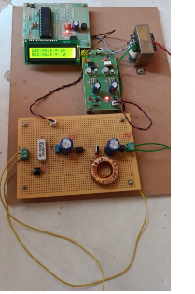

**CONCLUSIONS AND RECOMMENDATIONS:**

his paper proposes a method for integrating battery storage into multi-MW grid-connected PV systems through the use of a dc-dc converter, capable of simultaneously operating as a charge controller and MPPT device. Advantages of such a configuration include increased total energy output of the PV system, improved control of the PV system dc-link voltage during power curtailment, and higher system efficiency as compared with other commonly used approaches with multiple power converters. Furthermore, the proposed approach provides a relatively low cost for battery integrated PV systems without the need for an additional dc-dc converter for MPPT optimal control. A general approach for sizing dc-bus connected batteries to reduce the annual curtailed energy from utility-scale PV farms is developed. This approach evaluates the minimum battery size which can achieve substantial reductions in the annual solar energy curtailed. It was found that at the LG&E and KU site, a BESS power to energy capacity ratio of approximately 1:3 leads to substantial savings. Furthermore, a 1MW/2MWh battery is capable of retrieving up to 360MWh of the PV curtailed energy. The detailed technical benefits of the proposed configuration with respect to PV output power smoothing and variable power generation were illustrated through MATLAB simulations of two case studies with irradiance variation for a clear and cloudy day. Furthermore, the performance and steady operation of the proposed dc-dc converter and transition into multiple operation modes was verified. In order to validate the capabilities and effectiveness of the proposed system and controls, its simulated performance was compared with computed and experimental data from the LG&E and KU E.W. Brown universal solar facility, which houses a 10MW PV farm and a 1MW/2MWh BESS. The results show that for PV installations in an area with good solar PV resources and a lot of clear days, an increase in the annual capacity factor of up to 20% is possible with a dc-bus connected battery. At the other end, a negligible increase in the capacity factor for areas with limited solar availability is expected.

The present work proposes the need for and performs a detailed feasibility study for implementing wind and solar hybrid power system for rural electrification at the Estatuene Locality in the southern part of Mozambique. The results of the assessment made on the availability of energy resources in the study area show promising data for the implementation of the proposed system, as the annual average potential is approximately  5.02  m/s  for the  wind  velocity  resource  and  5.13  kWh/m2/day  for  the  solar  insolation resource, respectively.

The feasibility analysis was attempted in order to find the most appropriate system for the electrification of Estatuene combining the two energy sources (solar and wind) using the HOMER software. All system scenarios need also to contain a large battery bank to cover the necessary demand.

evaluation  considerations  resulted  in  three  optimal  options/scenarios  to  be  compared  among each-other in terms of performance and costs, namely:

* Solar energy system,
* Solar PV energy system alone,

However, once a critical analysis was made between these options it was concluded that the hybrid combination appears to be more technically and economically feasible, because the costs of electricity production using this system are lowest (0.34 $/kWh) compared to the other two options (0.37 $/kWh for  solar-only  and  0.82  $/kWh  for  wind-only)  and  also  involves  less  equipment  especially  in  terms  of energy storage devices (battery charge).

Despite the fact that the novelized cost of electricity for the hybrid system is lower, it is still an unbearably high investment for the economic capacity of rural communities in Mozambique, since even in urban areas that are covered by the national grid (supplied by EDM), the cost of electricity for domestic use is about 0.1 $USD/kWh. However, it is the government responsibility to supply electricity to citizens. So for this kind of projects, the Government of Mozambique and cooperating partners provide funds for implementation of rural electrification projects through FUNAE, and then it is up to the involved communities to contribute about 15 USD/Month/beneficiary and ensure the necessary local maintenance and operation-supporting procedures to keep the system properly running and to sustain the longevity of the equipment.

In Mozambique the measures for rural electrification funded by the Government through FUNAE are the implementation of small renewable energy systems, especially using PVs, but this technology has been

costly and technically impractical because these systems, in certain periods of the day or month, do not support the load demand due to insufficient availability of the resource, in turn requiring a prohibitively large energy storage auxiliary systems which further raise the costs. This situation could be overcome through the implementation of hybrid (wind-solar) power systems.

## Recommendations and future work

It is recommended that:

* Studies of this nature be transferred and implemented also in other parts of the country, to determine the feasibility for implementation of projects using renewables elsewhere in Mozambique; and
* The Astuteness project should be implemented in a pilot phase, so that later on it can be replicated to other regions of the country that yet have not been covered by the national grid authority EDM;
* Future socioeconomic analysis must be made to evaluate the possibility so that the rural communities  should pay  the  regular  EDM  electricity tariff (0.1  USD/kWh)  and the  remaining production cost (LCOE) inferred by renewable energy generation should be subsidized by the Government.

**REFERENCES**

1 F. Blaabjerg and D. M. Ionel, “Renewable energy devices and systems – state-of-the-art technology, research and development, challenges and future trends,” Electric Power Components and Systems, vol. 43, no. 12, pp. 1319–1328, 2020.

1. F. Blaabjerg and D. M. Ionel, Renewable Energy Devices and Systems with Simulations in MATLAB R and ANSYS R . CRC Press, 2019.
2. T. F. Wu, C. H. Chang, L. C. Lin, and C. L. Kuo, “Power loss comparison of single- and two-stage grid-connected photovoltaic systems,” vol. 26, no. 2, June 2021, pp. 707–715.
3. Y. Zhu, J. Yao, and D. Wu, “Comparative study of two stages and single stage topologies for grid-tie photovoltaic generation by MATLAB,” in 2021 International Conference on Advanced Power System Automation and Protection, vol. 2, Oct 2021, pp. 1304– 1309.
4. S. Jain, R. Karampuri, and V. T. Somasekhar, “An integrated control algorithm for a single-stage pv pumping system using an open-end winding induction motor,” IEEE Transactions on Industrial Electronics, vol. 63, no. 2, pp. 956–965, Feb 2020.
5. O. M. Akeyo, V. Rallabandi, and D. M. Ionel, “Multi-MW solar PV pumping system with capacity modulation and battery voltage support,” in 2022 IEEE 6th International Conference on Renewable Energy Research and Applications (ICRERA), Nov 2022, pp. 423–428.
6. A. Merabet, K. T. Ahmed, H. Ibrahim, R. Beguenane, and A. M. Y. M. Ghias, “Energy management and control system for laboratory scale microgrid based pv-battery,” IEEE Transactions on Sustainable Energy, vol. 8, no. 1, pp. 145–154, Jan 2021.
7. J. Sachs and O. Sawodny, “A two-stage model predictive control strategy for economic diesel-PV-battery island microgrid operation in rural areas,” IEEE Transactions on Sustainable Energy, vol. 7, no. 3, pp. 903–913, July 2021.
8. V. Karthikeyan and R. Gupta, “Varying phase angle control in isolated bidirectional dc 8211;DC converter for integrating battery storage and solar PV system in standalone mode,” IET Power Electronics, vol. 10, no. 4, pp. 471–479, 2021.
9. Y. Chang, Y. Feng, W. Chiang, R. Chang, M. Chiueh, and T. Holtz, “5kw dc-coupling distribution power generation system based on photovoltaic and aqueous hybrid ion battery,” in 2019 IEEE 3rd International Future Energy Electronics Conference and ECCE Asia (IFEEC 2019 - ECCE Asia), June 2019, pp. 1719–1724.
10. Kyohei Kurohane, T. Senjyu, Akie Uehara, A. Yona, T. Funabashi, and Chul-Hwan Kim, “A hybrid smart ac/dc power system,” in 2020 5th IEEE Conference on Industrial Electronics and Applications, June 2020, pp. 764–769.
11. T. Ma, M. H. Cintuglu, and O. A. Mohammed, “Control of a hybrid ac/dc microgrid involving energy storage and pulsed loads,” IEEE Transactions on Industry Applications, vol. 53, no. 1, pp. 567–575, Jan 2021.
12. M. Rezkallah, A. Hamadi, A. Chandra, and B. Singh, “Real-time HIL implementation of sliding mode control for standalone system based on pv array without using dumpload,” IEEE Transactions on Sustainable Energy, vol. 6, no. 4, pp. 1389–1398, Oct 2020.
13. O. Akeyo, V. Rallabandi, N. Jewell, and D. M. Ionel, “Improving the capacity factor and stability of multi-mw grid connected pv systems with results from a 1mw/2mwh battery demonstrator,” in 2021 IEEE Energy Conversion Congress and Exposition (ECCE), Sep. 2021, pp. 2504–2509.
14. V. Rallabandi, O. M. Akeyo, N. Jewell, and D. M. Ionel, “Incorporating battery energy storage systems into multi-mw grid connected pv systems,” IEEE Transactions on Industry Applications, vol. 55, no. 1, pp. 638–647, Jan 2019. 0093-9994 (c) 2019 IEEE. Personal use is permitted, but republication/redistribution requires IEEE permission.See ml for more information. This article has been accepted for publication in a future issue of this journal, but has not been fully edited. Content may change prior to final publication. IEEE Transactions on Industry Applications 10
15. H. Mahmood, D. Michaelson, and J. Jiang, “Strategies for independent deployment and autonomous control of PV and battery units in islanded microgrids,” IEEE Journal of Emerging and Selected Topics in Power Electronics, vol. 3, no. 3, pp. 742–755, Sept 2019.
16. N. A. DiOrio, J. M. Freeman, and N. Blair, “Dc-connected solar plus storage modeling and analysis for behind-the-meter systems in the system advisor model,” in 2018 IEEE 7th World Conference on Photovoltaic Energy Conversion (WCPEC) (A Joint Conference of 45th IEEE PVSC, 28th PVSEC 34th EU PVSEC), June 2018, pp. 3777–3782.
17. M. O. Badawy and Y. Sozer, “Power flow management of a grid tied PV-battery system for electric vehicles charging,” IEEE Transactions on Industry Applications, vol. 53, no. 2, pp. 1347–1357, March 2020.
18. N. Saxena, I. Hussain, B. Singh, and A. L. Vyas, “Implementation of a grid-integrated PV-battery system for residential and electrical vehicle applications,” IEEE Transactions on Industrial Electronics, vol. 65, no. 8, pp. 6592–6601, Aug 2021.
19. P. Satapathy, S. Dhar, and P. K. Dash, “Stability improvement of PVBESS diesel generator-based microgrid with a new modified harmony search-based hybrid firefly algorithm,” IET Renewable Power Generation, vol. 11, no. 5, pp. 566–577, 2019.
20. R. Teichmann and S. Bernet, “A comparison of three-level converters versus two-level converters for low-voltage drives, traction, and utility applications,” IEEE Transactions on Industry Applications, vol. 41, no. 3, pp. 855–865, May 2022.
21. Utility Scale Solar Inverter, Power Electronics.
22. S. Chen, T. Huang, S. S. Ng, K. Lin, M. Du, Y. Kang, K. Chen, C. Wey, Y. Lin, C. Lee, J. Lin, and T. Tsai, “A direct ac–dc and dc–dc cross-source energy harvesting circuit with analog iterating-based mppt technique with 72.5efficiency,” IEEE Transactions on Power Electronics, vol. 31, no. 8, pp. 5885–5899, Aug 2020.
23. A. Sangwongwanich, Y. Yang, and F. Blaabjerg, “A cost-effective power ramp-rate control strategy for single-phase two-stage grid-connected photovoltaic systems,” in 2021 IEEE Energy Conversion Congress and Exposition (ECCE), Sept 2021, pp. 1–7.
24. D. Cormode, A. D. Cronin, W. Richardson, A. T. Lorenzo, A. E. Brooks, and D. N. DellaGiustina, “Comparing ramp rates from large and small PV systems, and selection of batteries for ramp rate control,” in 2019 IEEE 39th Photovoltaic Specialists Conference (PVSC), June 2019, pp. 1805–1810.
25. W. A. Omran, M. Kazerani, and M. M. A. Salama, “Investigation of methods for reduction of power fluctuations generated from large grid-connected photovoltaic systems,” IEEE Transactions on Energy Conversion, vol. 26, no. 1, pp. 318–327, March 2021.
26. R. Yan and T. K. Saha, “Power ramp rate control for grid connected photovoltaic system,” in 2020 Conference Proceedings IPEC, Oct 2020, pp. 83–88.